* Prepare a document with details of the following along with their price

1. **Power BI Desktop**

DETAILS

* Connect to your data, wherever it is

### Prep and model your data with ease

### Provide advanced analytics with the familiarity of Office

### Deepen your data insights with AI-driven augmented analytics

### PRICE

FREE

### Power BI Pro

### DETAILS

* Self-service and modern BI in the cloud
* Collaboration, publishing, sharing, and ad-hoc analysis
* Fully managed by Microsoft

PRICE

660 Rupees

1. **Power BI Premium**

DETAILS

* Enterprise BI, big data analytics, cloud and on-premises reporting
* Advanced administration and deployment controls
* Dedicated cloud compute and storage resources
* Allows any user to consume Power BI content

PRICE

3,30,190 Rupees

* Install Power BI Desktop and share the final screenshot of the report view page which appears when power desktop starts.

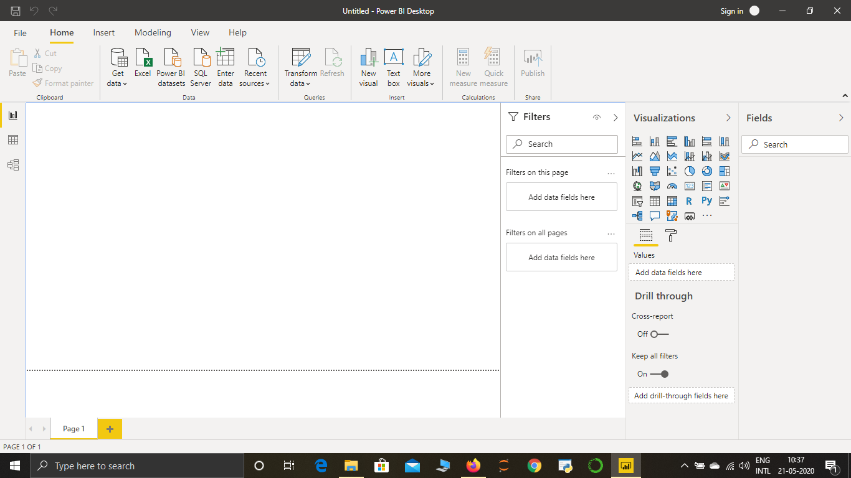

* Prepare a document and with the following screenshot
* −Report View
* −Data View
* −Model View
* −Power Query Editor
* −Advance Editor

